
SRM Institute of Science and Technology
RegNo
SET A
College of Engineering and Technology
School of Computing
DEPARTMENT OF COMPUTING TECHNOLOGIES
SRM Nagar, Kattankulathur – 603203, Chengalpattu District, Tamilnadu
Academic Year: 2022-2023 (EVEN)
Test: CLAT-3 Date: 05.05.2023
Course Code & Title: 18CSE360T-Information Storage and Management Duration: 8.00 am to 9.40am
Year & Sem: III/ VI Max. Marks: 50

Course Articulation Matrix:
Sl.No | Course Outcomes | PO1 | PO2 | PO3 | PO4 | PO5 | PO6 | PO7 | PO8 | PO9 | P10 | P11 | P12
1 | CO1 | 2 | - | - | - | - | - | - | - | - | - | 2 | -
2 | CO2 | 2 | 2 | 2 | - | - | - | - | - | - | - | - | -
3 | CO3 | 2 | 2 | 2 | - | - | - | - | - | - | - | - | -
4 | CO4 | 2 | 2 | 1 | - | - | - | - | - | - | - | - | -
5 | CO5 | 1 | 2 | - | - | - | - | - | - | - | - | - | -
6 | CO6 | 2 | - | - | - | - | - | - | - | - | - | 2 | -

Part – A (10 x 1 = 10 Marks)
Answer all Questions
Q. No | Question | Mark |  | BL | CO | PO | PI Code
1 | Which of the following refers to a situation in which any existing security threat in the cloud spreads more rapidly in cloud infrastructures.  - Velocity of Function c. Data privacy  - Information assurance d. Data protection | 1 |  | 2 | 4 | 2 | 2.5.2
2 | A Single point of security failure for all the VMs running on the cloud infrastructure will happen in -------------------.  - Physical server c. Hypervisor  - Supervisor d. Controller | 1 |  | 2 | 4 | 2 | 2.5.2
3 | Which of the following is not a cloud enabling technology?  - Grid Computing c. Virtualization  - Utility Computing d. Edge Computing | 1 |  | 2 | 4 | 2 | 2.5.2
4 | Redundancy has to be implemented at the architectural level for effective results in cloud computing.  a. Lower b. Higher  c. Middle d. Poor Performances | 1 |  | 1 | 4 | 2 | 2.5.2
5 | Which of the following protocol is used for discovering and  retrieving objects from a cloud?  a. OCCI b. SMTP  c. HTTP d. TCP/IP | 1 |  | 2 | 4 | 2 | 2.5.2
6 | Which of the following is the correct statement about cloud types?  - Cloud Square Model is meant to show is that the traditional notion of a network boundary being the network’s firewall no longer applies in cloud computing  - A deployment model defines the purpose of the cloud and the nature of how the cloud is located.  - Service model defines the purpose of the cloud and the nature of how the cloud is located.  - Cloud services modules. | 1 |  | 2 | 5 | 1 | 1.5.1
7 | In which one of the following, a strategy record or Document is created respectively to the events, conditions a user may face while applying cloud computing mode.  - Cloud Computing Value Proposition  - Cloud Computing Strategy Planning  - Planning Phase  - Business Architecture Development | 1 |  | 2 | 5 | 1 | 1.5.1
8 | Which is referred to the amount of time and effort required to exploit an attack vector?  - Attack surface c. Attack vector  - Work factor d. DOS | 1 |  | 2 | 5 | 2 | 2.7.1
9 | A control mechanism on the switches that segments the network in to specific paths to be used for data traffic is called  - LNU c. Zoning  - ACL d. Role based control access | 1 |  | 1 | 5 | 2 | 2.7.1
10 | What type of computing technology refers to services and applications that typically run on a distributed network through virtualized resources?  - Cloud Computing c. Soft Computing  - Parallel Computing d. Distributed Computing | 1 |  | 2 | 6 | 1 | 1.7.1
Part – B ( 4 x 5 = 20 Marks)
Answer All the Questions
11 | Elaborate storage security domain and threats in each domain. | 5 | 3 |  | 4 | 2 | 2.5.2
12 | Compare active and passive attacks with examples | 5 | 2 |  | 4 | 2 | 2.5.2
13 | Containers create an isolation boundary at the application level rather than at the server level. If anything goes wrong in that single container - for example, excessive consumption of resources by a  process, in such cases elaborate how the containers will handle the situation write up with a solution. | 5 | 4 |  | 5 | 2 | 2.5.2
14 | Discuss in detail about the enabling technologies of the cloud computing. | 5 | 2 |  | 6 | 1 | 1.7.1
Part – C ( 2 x 10 = 20 Marks)
Answer All the Questions
15 | a. Explain the process of security implementation in SAN. | 10 | 2 |  | 6 | 1 | 1.7.1
OR
 | b. Elaborate how containers are built on virtualization technique and How they offer an alternative to virtual machines. | 10 | 3 |  | 4 | 2 | 2.5.2
16 | a. Sketch the any ten tools of cloud computing. | 10 | 2 |  | 6 | 1 | 1.7.1
OR
 | b. Develop a checklist for auditing the security of a storage environment with SAN, NAS, and iSCSI implementations. Explain how you will perform the audit. Assume that you discover at least five security loopholes during the audit  process. List them and provide control mechanisms that should be implemented to eliminate them. | 10 | 3 |  | 4 | 2 | 2.5.2

Course Outcome (CO) and Bloom’s level (BL) Coverage in Questions
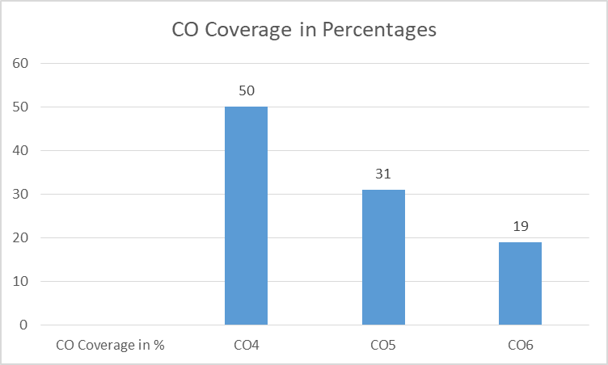
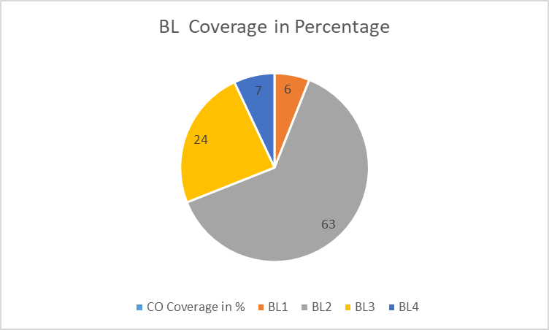
SRM Institute of Science and Technology
RegNo
SET B
College of Engineering and Technology
School of Computing
DEPARTMENT OF COMPUTING TECHNOLOGIES
SRM Nagar, Kattankulathur – 603203, Chengalpattu District, Tamilnadu
Academic Year: 2022-2023 (EVEN)
Test: CLAT-3 Date: 05.05.2023
Course Code & Title: 18CSE360T-Information Storage and Management Duration: 10.30 am to 12.10 pm
Year & Sem: III/ VI Max. Marks: 50

Course Articulation Matrix:
Sl.No | Course Outcomes | PO1 | PO2 | PO3 | PO4 | PO5 | PO6 | PO7 | PO8 | PO9 | P10 | P11 | P12
1 | CO1 | 2 | - | - | - | - | - | - | - | - | - | 2 | -
2 | CO2 | 2 | 2 | 2 | - | - | - | - | - | - | - | - | -
3 | CO3 | 2 | 2 | 2 | - | - | - | - | - | - | - | - | -
4 | CO4 | 2 | 2 | 1 | - | - | - | - | - | - | - | - | -
5 | CO5 | 1 | 2 | - | - | - | - | - | - | - | - | - | -
6 | CO6 | 2 | - | - | - | - | - | - | - | - | - | 2 | -

Part – A (10 x 1 = 10 Marks)
Answer all Questions
Q. No | Question | Mark | BL | CO | PO | PI Code
1 | How many types of security domains are there?  a. 2 b. 3 c. 4 d. 5 | 1 | 2 | 4 | 2 | 2.5.2
2 | What is ACL?  - Access Control list  - Accountability Control List  - Access confidentiality list  d. Access Control Layer | 1 | 2 | 4 | 2 | 2.5.2
3 | Cloud consumers that install or lease virtual servers can customize their environments independently from other cloud consumers that may be using hosted by the same underlying physical server.  - Ready-Made Environment c. Cloud Storage Device  - Virtual servers d. Resource Replication | 1 | 1 | 4 | 2 | 2.5.2
4 | The major storage infrastructure components that should be managed are  - Storage Arrays c. Redundant Fabrics  - Multipathing software d. RAID sets | 1 | 2 | 4 | 1 | 1.4.1
5 | is the feature of cloud computing that allows the service to change in size or volume in order to meet a user’s needs.  - Scalability c. Virtualization  - Security d. Cost-savings | 1 | 1 | 5 | 2 | 2.5.2
6 | Which of the following is the most refined and restrictive cloud service model?  - SaaS c. IaaS  - PaaS d. CaaS | 1 | 2 | 5 | 2 | 2.5.2
7 | Which of the following is the most common way to approach the problem of interoperability by vendors?  - Cloud Maintances  - create scalable websites for different devices  - create reliable websites for different devices  - create individual sites within a Web site for different devices | 1 | 2 | 5 | 2 | 2.5.2
8 | Logical Unit Number masking prevents data corruption on the storage array by restricting host access to a defined set of logical devices  - Data security c. Data redundancy  - Data reduplication d. Data corruption | 1 | 2 | 5 | 2 | 2.5.2
9 | Which of the following is not a cloud infrastructure mechanisms?  - Logical Network Perimeter c. Cloud Usage Monitor  - Flexible scaling d. Virtual server | 1 | 2 | 5 | 2 | 2.5.2
10 | An application that provides for transaction overflow in a reservation system is an example of  - Cloud Bursting c. Cloud Prevising  - Cloud Services d. Cloud Orchestrate | 1 | 2 | 6 | 1 | 1.7.1
Part – B ( 4 x 5 = 20 Marks)
Answer All the Questions
11 | Describe the Risk Triad in information storage. | 5 | 3 | 4 | 2 | 2.5.2
12 | Explain vulnerable factors in storage security. | 5 | 3 | 4 | 2 | 2.5.2
13 | A performance problem has been reported on a database. Monitoring confirms that at 12:00 a.m., a problem surfaced, and access to the database is severely affected until 3:00 p.m. every day. This time slot is critical for business operations and an investigation has been launched. A reporting process that starts at 12:00 p.m. contends for database resources and constrains the environment. What monitoring and management procedures, tools, and alerts would you establish to ensure accessibility, capacity, performance, and security in this environment | 5 | 4 | 4 | 2 | 2.7.1
14 | Enumerate the characteristics and benefits of cloud computing. | 5 | 3 | 6 | 1 | 1.7.1
Part – C ( 2 x 10 = 20 Marks)
Answer All the Questions
15 | a. List out and explain the management tasks in a storage infrastructure. | 10 | 2 | 6 | 1 | 1.7.1
OR
 | b. Outline the cloud service models and also analyze the benefits of cloud computing. | 10 | 3 | 6 | 1 | 1.7.1
16 | a. Enumerate the cloud infrastructure mechanisms, explain any three of the mechanisms in detail. | 10 | 3 | 5 | 2 | 2.5.2
OR
 | b. Illustrate the working model of Resource replication in cloud environment. | 10 | 3 | 6 | 1 | 1.7.1

Course Outcome (CO) and Bloom’s level (BL) Coverage in Questions
